**MEDICINE HAT CATHOLIC BOARD OF EDUCATION  
Welcome to our Catholic Schools**

**INDIGENOUS INFORMATION AT A GLANCE**

C:\Users\della.dewald\AppData\Local\Microsoft\Windows\Temporary Internet Files\Content.IE5\WM6TPTKX\MC900065967[1].gif

**INDIGENOUS & MEDICINE HAT CATHOLIC SCHOOLS**  
We are committed to improving educational outcomes for First Nations, Métis, and Inuit (Indigenous) students by engaging families and supporting students.

**Our Goal:**Delivery of Educational Indigenous Services.

**Our Vision**:   
Celebrate Indigenous Cultures, Gather Together and Share, Respect Diversity and Build a Future with Christ.

**Our Services**:   
Indigenous Resources for Families/Parents/Teachers  
Indigenous Awareness Team Building   
Indigenous Curriculum Development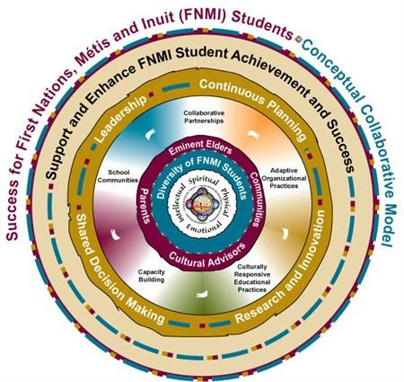

Indigenous Cultural Development   
Promotion of Healthy Active Living Culturally  
Awareness of Racial Harmony

**We Offer**:   
A Community Helpers Program directing families, students and teachers; resources, support and training.  
Youth Self Esteem Programs:

* Enhance Pride and Cultural Identity
* Academic Tutoring
* Storytelling
* Modified Curriculum Studies
* Specialized Classroom Lessons/Presentations

**We Support Students and Families**:

* Liaise and assist students, staff and parents in understanding Indigenous heritage.
* Teach Indigenous based material.
* Cultural Clarification and Cultural Balance through Classroom Instruction, Group & Individual Sessions, Cultural Professional Development opportunities, and Medicine Wheel Teachings.

**PLEASE email or call us. Let us tell you about our services. Miigwetch.**Rod Willier, Indigenous Support Worker, [rod.willier@mhcbe.ab.ca](mailto:rod.willier@mhcbe.ab.ca)

|  |  |
| --- | --- |
|  | **MEDICINE HAT CATHOLIC BOARD OF EDUCATION Aboriginal Learners Data Collection Incentive (ALDCI)** |

**INFORMATION FOR PARENTS**

**What is the purpose of the Aboriginal self-identification question on the school registration form?**

The ALDCI was introduced to identify First Nations, Métis, and Inuit (FNMI) students in the province for the purpose of helping to improve education programs and achievement for FNMI learners. This information helps Alberta Education and school authorities to understand FNMI student achievement and is used to determine the FNMI funding allocation provided to school authorities to improve learning outcomes and enhance success for FNMI students. Answering the Aboriginal self-identification question is voluntary.

**How will FNMI student data be used?**

Alberta Education and school authorities will use the information to plan program improvements, to make policy and funding decisions, and to measure and report FNMI student achievement. Student achievement measures include student high-school completion rate, dropout rate, transition rate from high-school to post-secondary education, and Provincial Achievement and Diploma examination results.

**How will my child benefit from answering the voluntary self-identification question?**

Knowing how FNMI students are doing in school will help Alberta Education and school authorities to understand what programs are working, where additional supports and programs are required, and what changes may be needed to improve the education system for the benefit of FNMI students.

**Does this voluntary identification question apply to First Nations schools attending a band operated school?**

No. The ALDCI applies only to First Nation students attending schools off-reserve in Alberta. Some First Nation students living on reserve, attending school off-reserve may choose to self-identify as First Nations for data collection purposes.

**How do I know if my child is First Nations, Métis, or Inuit?**

Alberta Education does not define or verify Aboriginal identity. Aboriginal identity is best explored or determined by each individual family.

**Will anyone else (besides Alberta Education and necessary school personnel) know my children’s name, grade, or marks?** No. Schools must ensure confidentiality of student information is maintained and that all children are treated with respect. Your child’s personal information is managed and protected by Alberta’s privacy laws, the *Freedom of Information and Protection of Privacy Act (FOIP),* the *Personal Information and Protection Act (PIPA)*, the *School Act*, and the *Student Record Regulation*.

**Who can I contact to find out more about the ALDCI?** For the further information about the collect of FNMI student data please contact the office of the Director, Strategy and Systems Supports, First Nations, Métis and Inuit Education Directorate, Alberta Education, 10155-102 Street, Edmonton Alberta, T5J 4L5, (780) 427-8501.